NAME:...........................................................SIGNATURE........................................

**ST.ANDREW KAGGWA GOMBE HIGH SCHOOL-BUJUUKO**

**END OF YEAR CYCLE ASSESSMENT**

**PHYSICS**

**SENIOR THREE**

**TIME: 2:15minutes**

**INSTRUCTIONS**: Attempt 4 questions from this paper

**QUESTION 1**

On a construction site all materials that a bought to be used first go under a mechanical test. If a material is to be accepted its young's modulus **must exceed 2×10⁷Nm-²**. The table below shows some of the materials that were bought on a certain day.



|  |  |  |  |  |
| --- | --- | --- | --- | --- |
| Material | Quantity bought | Unit price | Stress under gone(Nm-²) | Strain under gone |
| Nails | 50kg | 6000 | 3×10³ | 1.5×10-³ |
| Iron sheets | 100 pieces | 35000 | 6×10⁴ | 2×10-3 |
| Steel bars | 50 pieces | 12000 | 1.2×10⁷ | 2×10-4 |

1. If the materials reached at the sited. Determine the amount of money that was wasted.(10scores)
2. With reasons which materials would you recommend for use in the construction of (5scores)
3. The foundation
4. The windows
5. Roofing

QUESTION 2

After winning a singing competition, Brenda decided to buy a piece of land from one of the property consultants in the her community to start her projects. she was shown two plots A and B of the **same price** but different measurements, **plot A** was measuring **45m by 100m** while **plot B** was measuring **70m by 80m.**



Task

1. With a reason which plot would u advise Brenda to buy(7scores)
2. The head teacher ordered the carpenter to make a notice board for the school, the noticed board measured 150cm by 100cm after being made. If the head teacher is to fully use the notice board by pinning documents measuring 30cm by 15cm. what is the maximum number of documents that can be pinned on the board on a given day (8Scores)

**QUESTION 3**

In a certain TV show, a set of games in which the winner gets a good prize for the challenge(s) is aired , Joel a S.3 student at St.Andrew Kaggwa Gombe high school joins the competition and finds out that he was required to climb **9 steps** each of height **15cm** to move a load of mass **25kg.** On reaching the top ,he discovered that he had to carry a load of **65kg** for a distance of **2m** upto the finish point for a duration of **5minutes**



**Task:** You are one of the judges on this show and your role is to compute the following

1. The work done as he climbs the steps upto the last one
2. Work done when he is carrying a load of **65kg** for the distance of **2m**
3. Power used when carrying the load for **5minutes (10scores)**
4. During one prep at school , there was a power black out and the askari decided to use the school generator as a power source. Describe the energy changes that took place when the generator was switched on to light the filament bulbs at school(5scores)

**QUESTION 4**

As you carry out your research using a concave mirrors of focal length 10 cm, the mirror accidentally drops on the floor and gets broken. When you go to collect another concave mirror , you realise that Mr. Ocen, the lab technician is not around. However, there is a box containing several convex and concave mirrors of different focal lengths from which you have to pick a similar concave mirror of focal length 10 cm.

1. How would you differentiate between a convex and concave mirrorsfrom the box.
2. Briefly describe a quick method of how you would determine the focal length of the mirror that you want. (15scores)

**QUESTION 5**

Sound is quite a useful form of energy in daily life

1. Identify any three properties of sound(3scores)
2. A certain radio station Broad casts at a frequency of 3×10⁶Hz determine the wavelengthof waves produced if the velocity is 3×10⁸ms-¹**(3 scores)**
3. **How can you use** (an electric bell inside a jar having one outlet leading to a source of electricity connected to the bell and the other outlet leading to a vacuum pump) **to demonstrate the effect of** **air on movement of sound 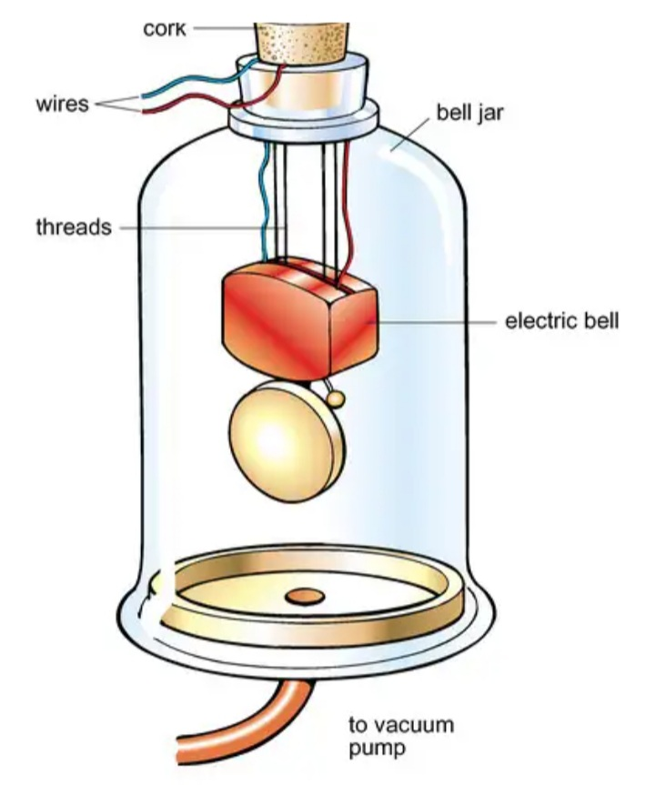 (5 scores)**
4. A girl stands 640m from a wall and makes loud sound. After 4 seconds, she hears her sound repeated by the wall
5. Account for the sound from the wall **(1score)**
6. Establish how fast the sound was moving based on the measurements given **(3 scores)**